Team Composition and Project Overview
Team Composition and Project Overview

1. Team Charter
- Samson, Marriane Angel - Project Manager
- Senoran, Earlstephen - Frontend Specialist
- Sapinoso, Michael - Backend/Database Engineer
- Ramos, Jeric - QA/Develops Lead

2. Overview of the Simulated Client

FleetFoam is a mobile vehicle detailing business managed by Brooke Sterling, Operations Director. Unlike a traditional detailing shop, FleetFoam sends its crews directly to the customers' locations. Because of this business model, booking, scheduling, crew assignment, job status tracking, and routing are essential to daily operations.
- Detailing Crews – can view their assigned jobs, customer information, service details, location, daily schedule, and update the status of each job.

The proposed web system will serve three main users:

- Customers – can select a detailing service, enter their location, choose a date and time, and book an appointment using their phone.
- Operations Team – can monitor bookings, crew schedules, cancellations, delays, and eventually crew locations through a live map.

The first version should prioritize reliable bookings, crew scheduling, job-status updates, and a fast mobile experience. This follows the course's focus on production-grade software, client alignment, accessibility, security, performance, and maintainability.

3. Approaches and Solutions to the Client Problem
A. Customer Booking System

Create a mobile-first booking interface where customers can:

- Select a detailing service.
- Enter their vehicle information.
- Provide their service location.
- Select an available date and time.
- Review the booking.
- Confirm the appointment.

The system should check availability before confirming the booking so that two customers cannot accidentally reserve the same crew at the same time.

B. Crew Scheduling and Assignment

The backend should maintain information about:

- Crews
- Crew availability
- Existing appointments
- Service duration
- Customer locations
- Assigned jobs

When a customer selects a schedule, the system can determine whether a crew is available during that period.

A booking should only be accepted if it does not conflict with an existing appointment.

C. Job Status Tracking

Provide crews with a simple mobile dashboard containing large, obvious status controls:

Scheduled → On the Way → Arrived → In Progress → Completed

If a customer cancels, the crew's dashboard should immediately reflect the cancellation.

This also gives the operations team visibility without requiring them to repeatedly call the crew.

D. Operations Dashboard

Create a dashboard for the operations team where they can see:

- Today's appointments
- Assigned crews
- Job status
- Delayed jobs
- Cancelled appointments
- Upcoming bookings
- Crew schedules

This provides a central place for Brooke and the operations team to monitor the business.

E. Location and Routing — Future Enhancement

The client's eventual goal is a live map showing crew locations. For the MVP, however, this should be treated as a future feature rather than making it unnecessarily complex.

A possible future implementation could include:
- Periodic crew location updates
- Role-based access to location information
- Offline handling when connectivity is lost
- Estimated arrival time for customers
- Exact location visibility restricted to authorized operations personnel

For privacy and simplicity, customers could initially see estimated arrival time rather than the crew's exact GPS location.

F. Mobile-First and Performance-Focused Design

Because crews work outdoors and may use phones with limited connectivity, the interface should have:

- Large buttons
- Minimal navigation
- Clear status indicators
- Responsive layouts
- Fast-loading pages
- Simple forms
- Accessible controls

The course specifically requires responsive, performant, intuitive interfaces and WCAG 2.1 AA accessibility.

G. Secure Role-Based Access

The system should have different permissions for:

User | Main Access
Customer | Create and view own bookings
Crew | View assigned jobs and update job status
Operations/Admin | Manage bookings, crews, schedules, cancellations, and monitoring

The backend should enforce these permissions rather than relying only on the frontend. The course emphasizes JWT authentication, protected API routes, RBAC, password hashing, and server-side authorization.

H. Testing and Deployment

The system should use automated testing and CI/CD so that changes can be checked before deployment. The course recommends GitHub Actions for linting and automated tests, including unit, integration, and E2E testing.

4. Recommended Tech Stack
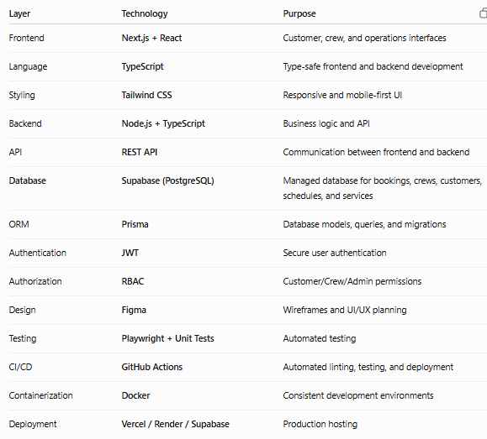
Recommended Architecture

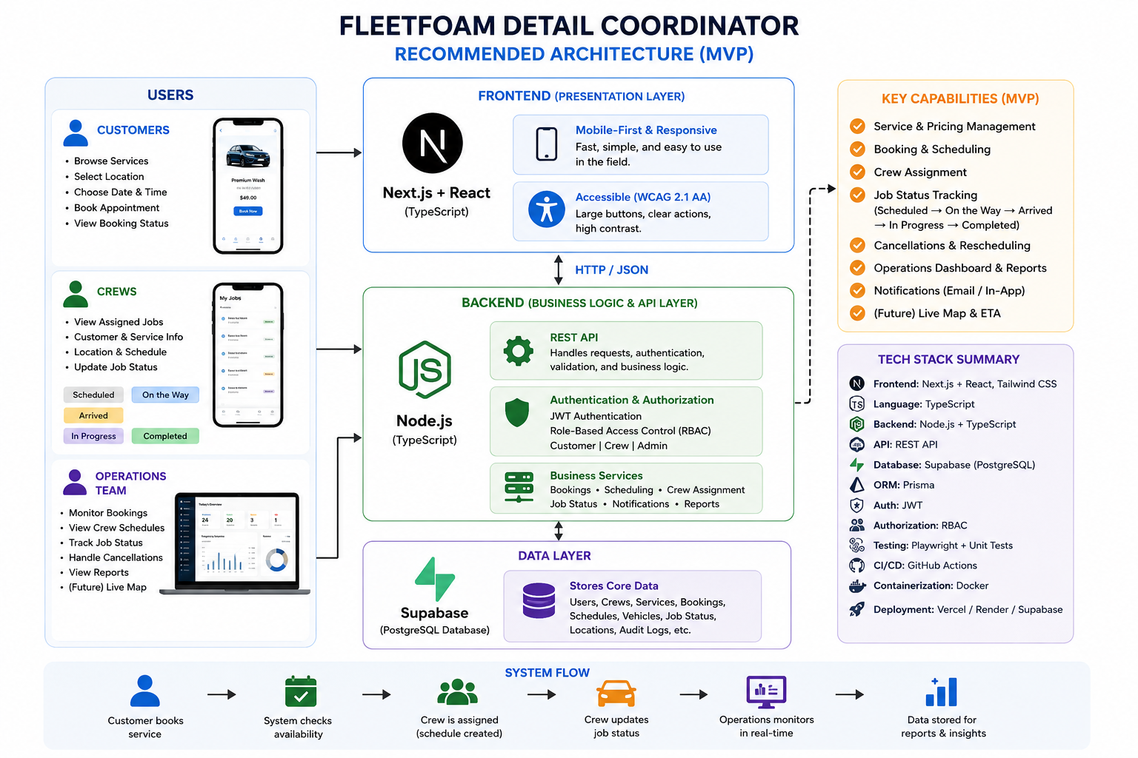

Overall Solution

In short, FleetFoam Detail Coordinator would be a mobile-first full-stack scheduling and operations system that connects customers, detailing crews, and the operations team.

The MVP should concentrate on:
Booking → Crew Assignment → Schedule → Job Status → Operations Monitoring

Then, after the core system is stable, features such as live crew tracking, ETA calculation, route optimization, push notifications, and offline synchronization can be added. This approach keeps the first release within a realistic MVP scope, consistent with the course's emphasis on delivering functional software first and handling additional scope through structured backlog changes.

